**37.AWS-Inspector-Cognito-RAM-WAF-Others**

**Inspector**

Inspector only for EC2 machines

For eg you deployed environment and then will hand over project to the client. Before hand over to the client you have to check your EC2 for any type of problems (CVE – COMMON VUNARABULITY AND EXECPTIONS)

--- the inspector works based on EC2 instance tag.

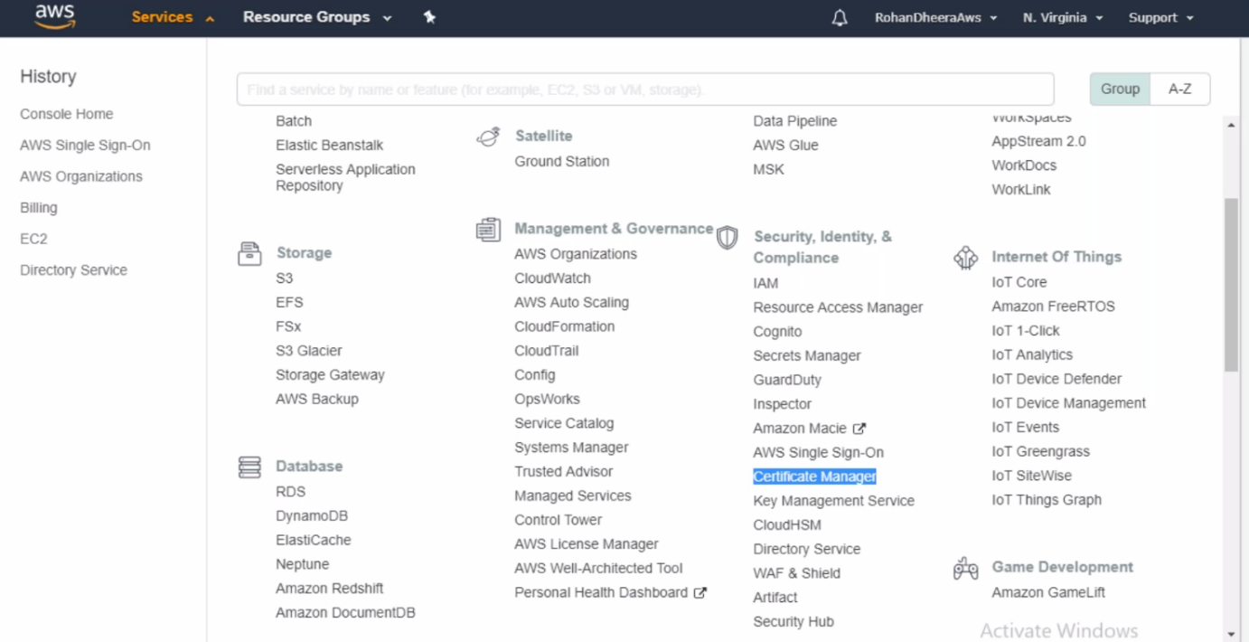

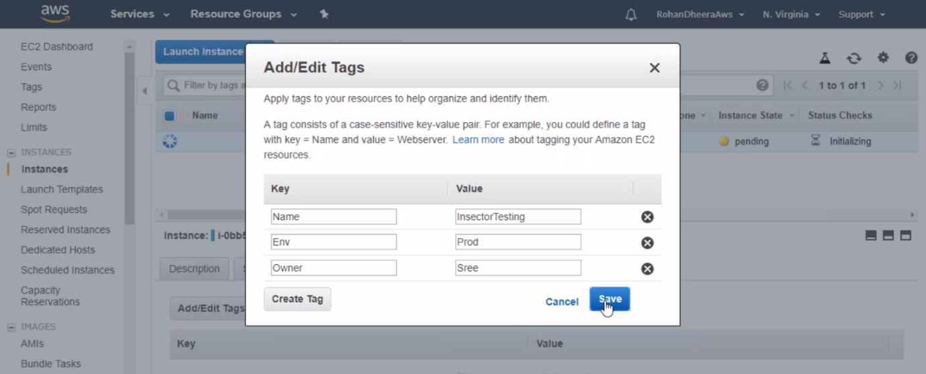

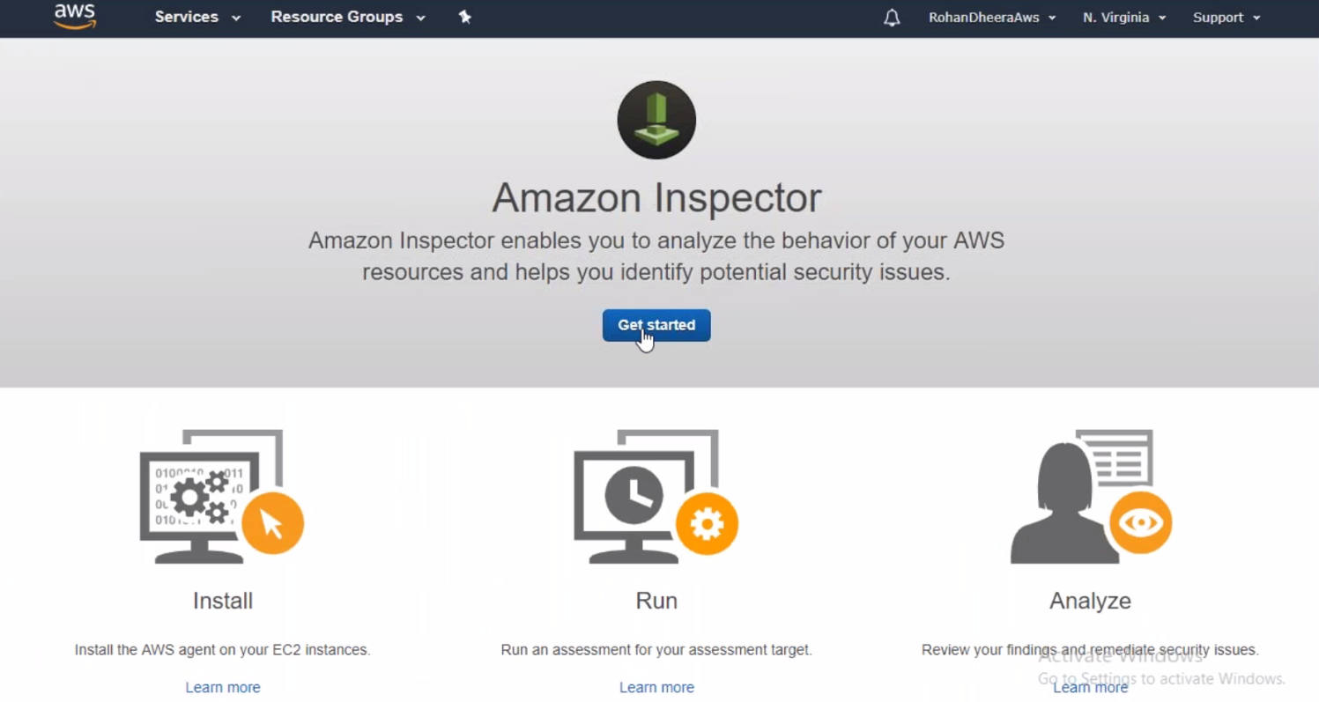

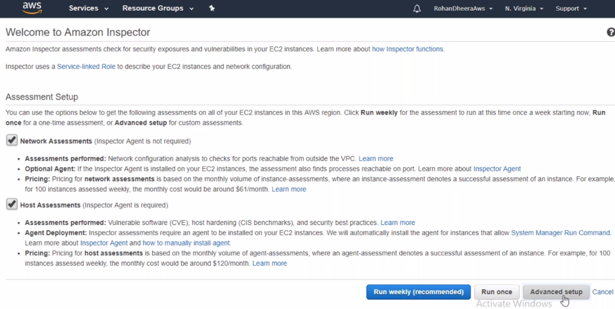

**Inspector Agent**

Inspector agent is needs to be installed in the EC2 instance in order to work Amazon inspector

--- AWS inspector agent install – type this in google to get installation method.

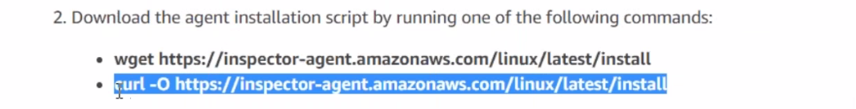

--- run the above script and you will get install folder along with script

--- give execute permission to script and then execute script.

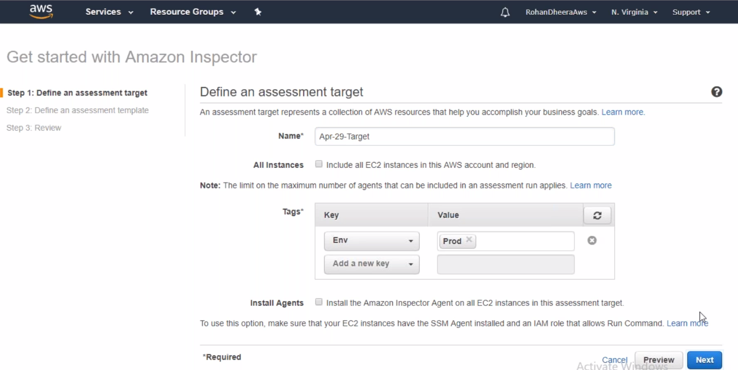

--- mention here your EC2 instance tags

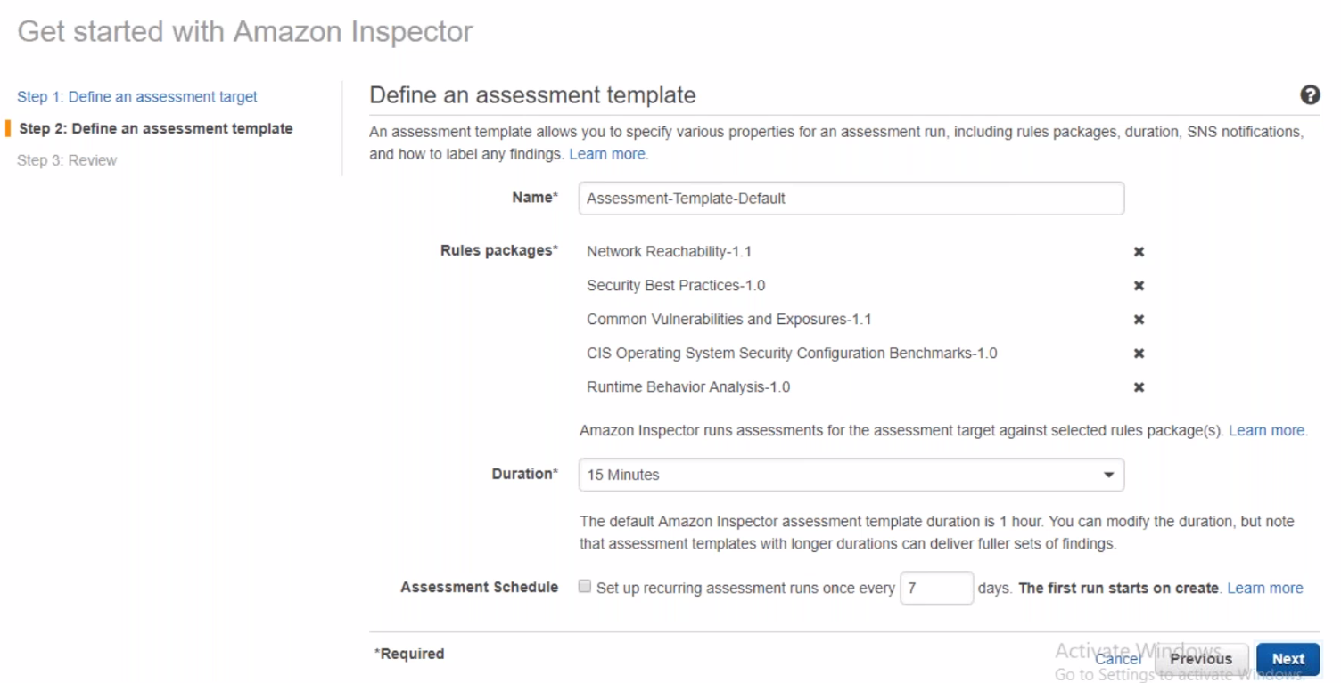

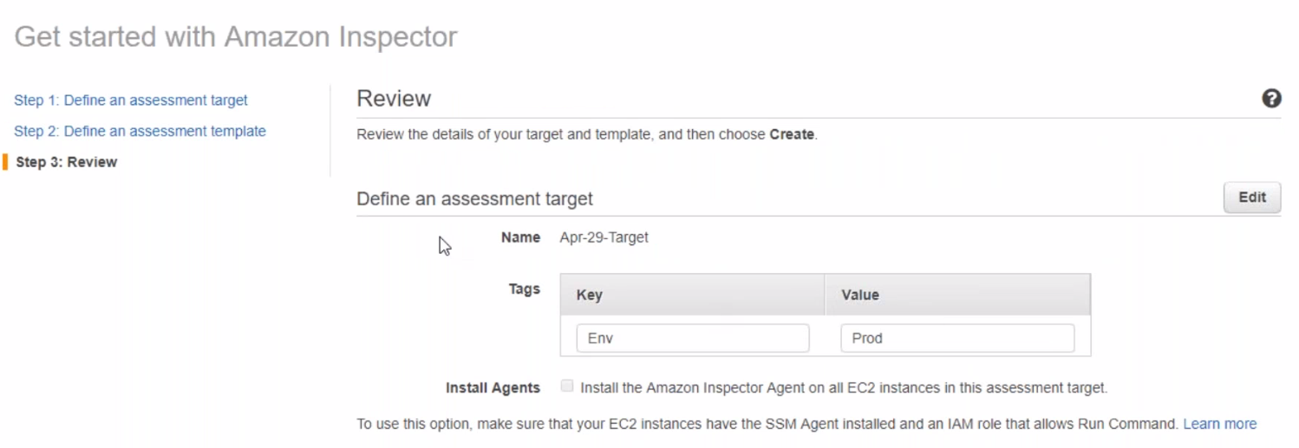

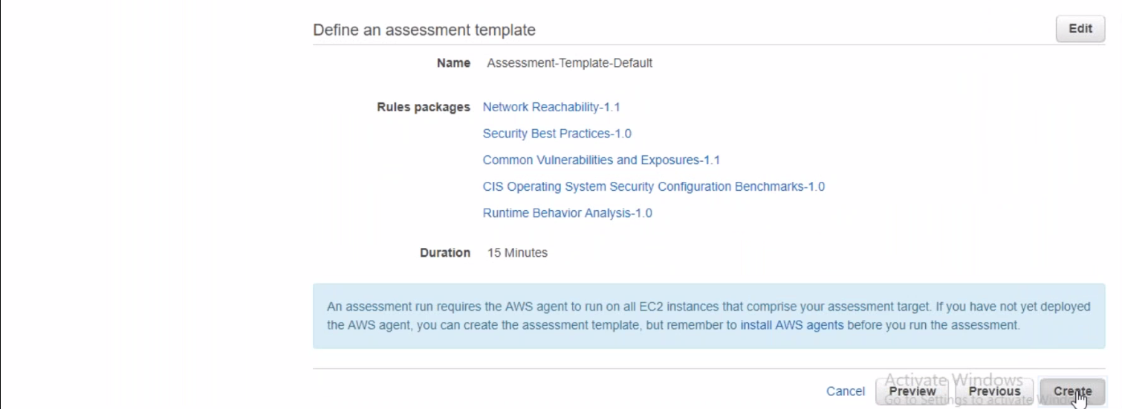

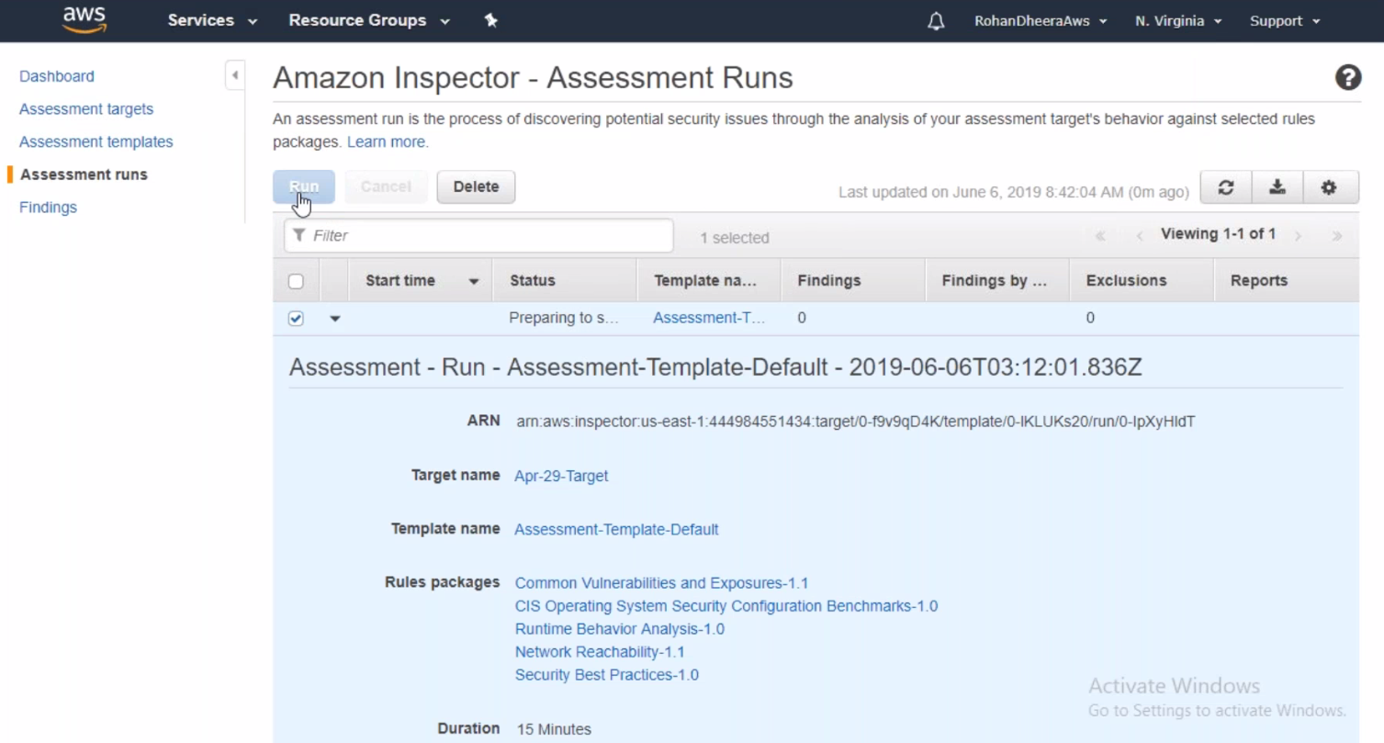

--- click on run to run the Amazon inspector in the EC2 instance.

**Amazon-Cognito**

We use Amazon-cognito for web application.

This is mainly for developers not for admins

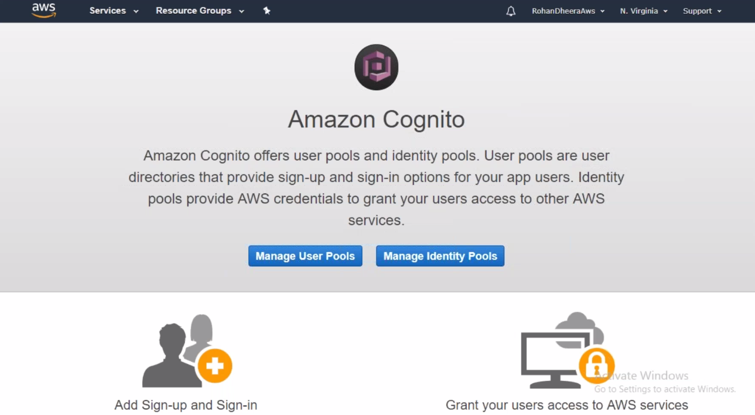

**AWS Resource Access Manager**

Share AWS resources with other AWS Accounts

This feature supports region to region

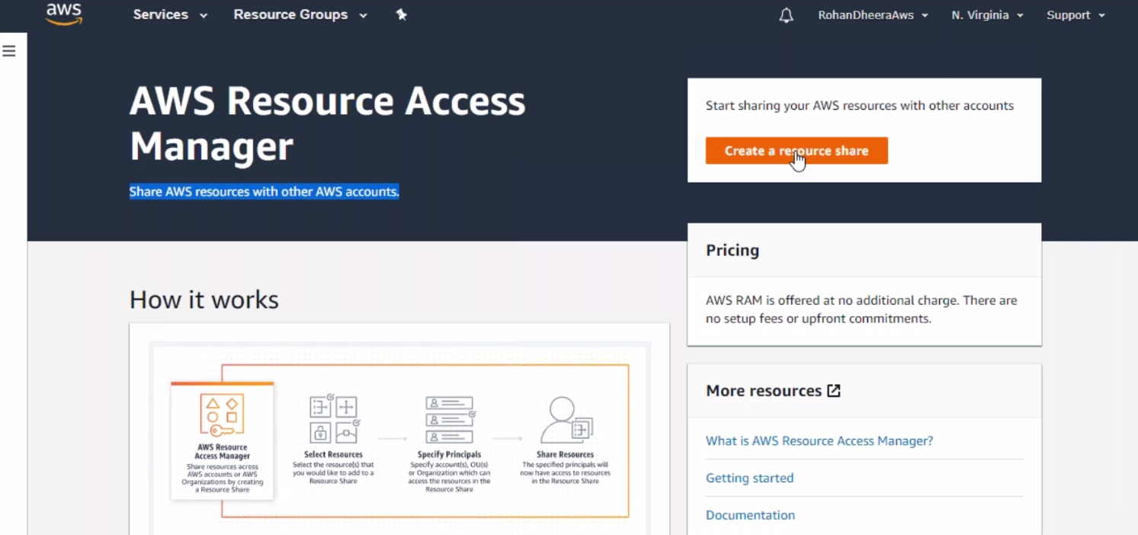

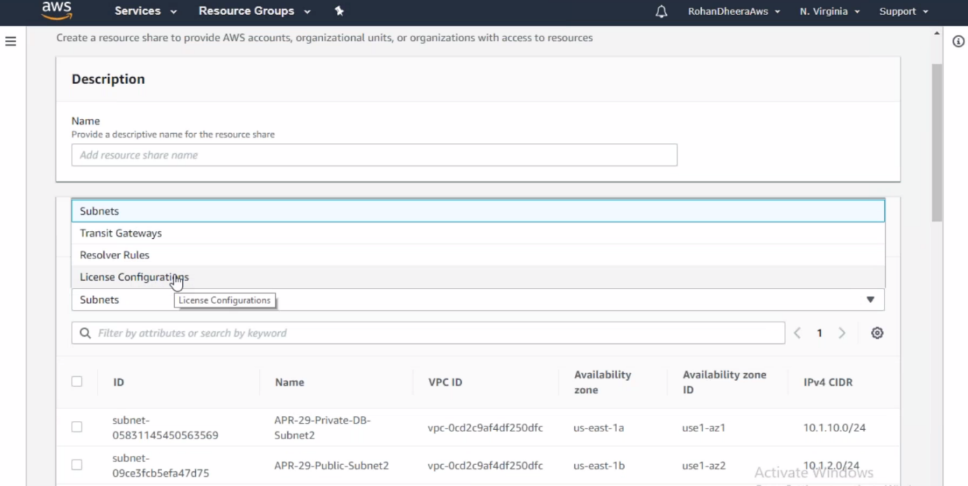

--- we can share above resource using this feature.

--- among these feature subnet feature very use full.

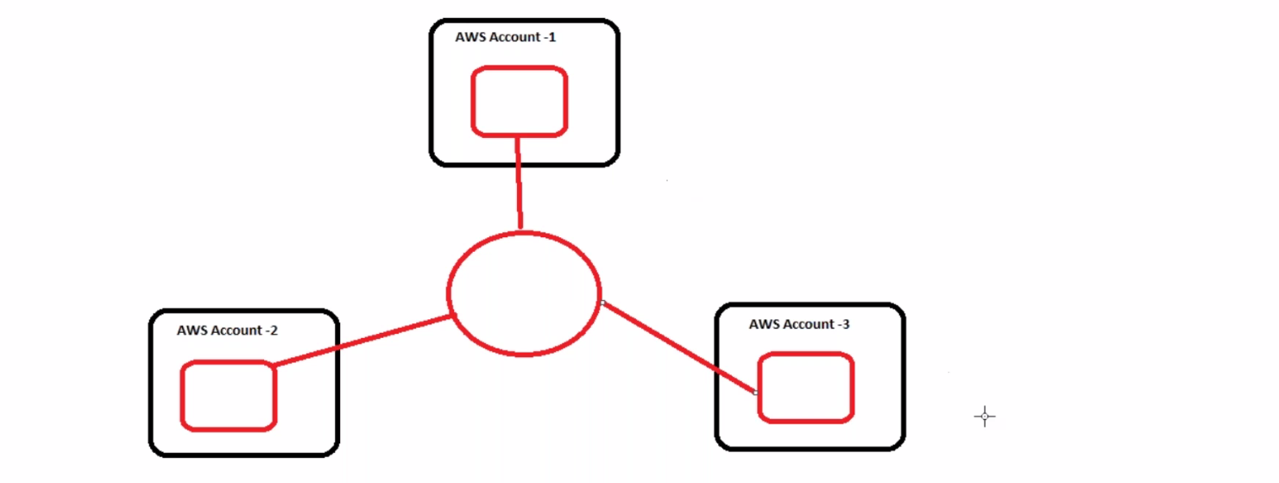

If you have three servers in three different AWS account and you want to communicate these servers with each other. So you need to deploy these EC2 instance in single subnet. By using this RAM feature to share the subnet so you can deploy all the servers in single subnet.

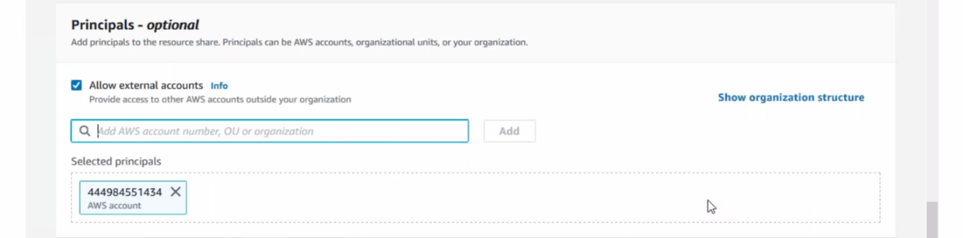

--- give other AWS account ID

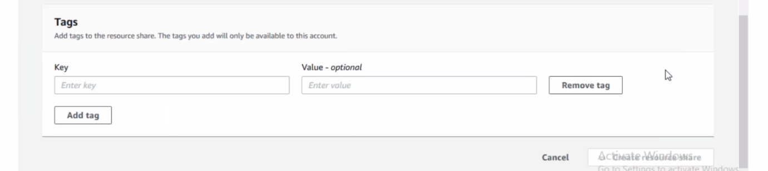

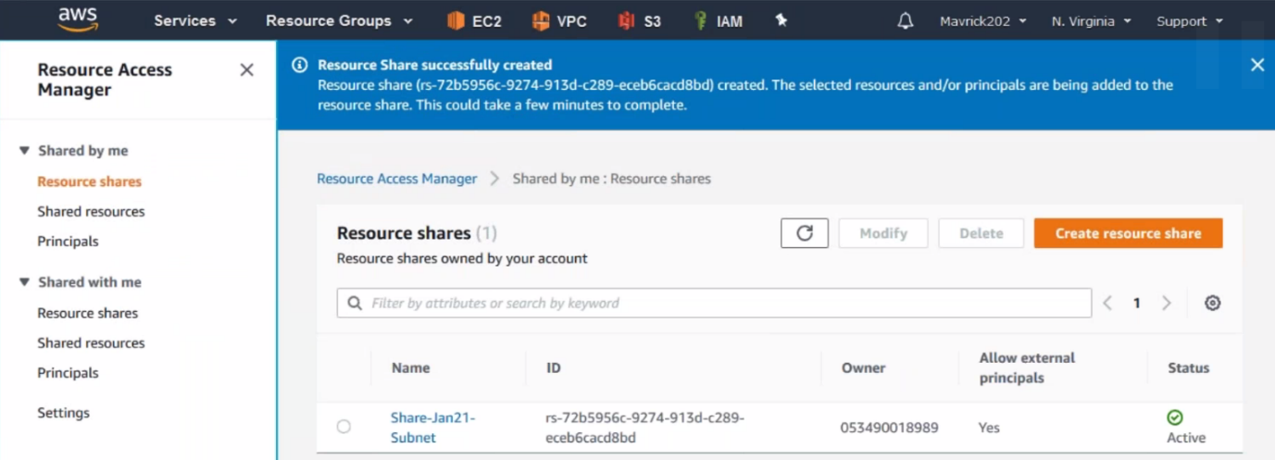

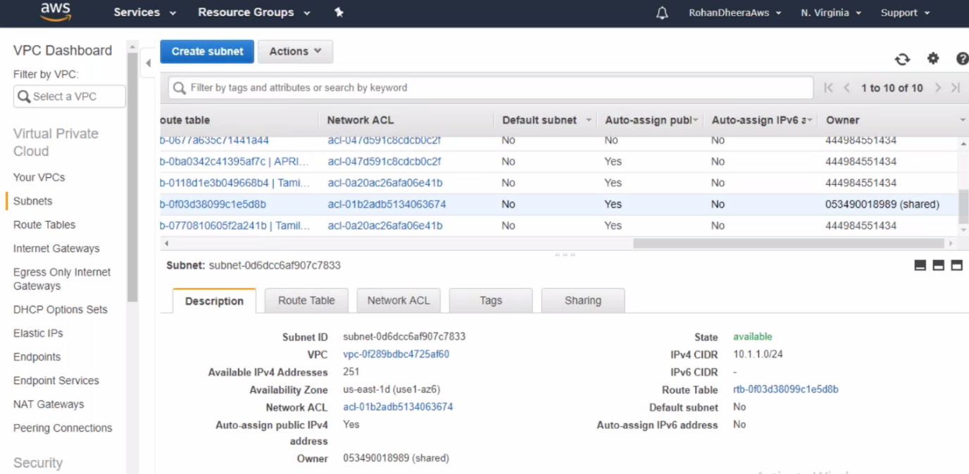

--- now you can see the shared subnet in other AWS account. Now you can start deploy EC2 instance in this subnet.

**AWS Secret Manager**

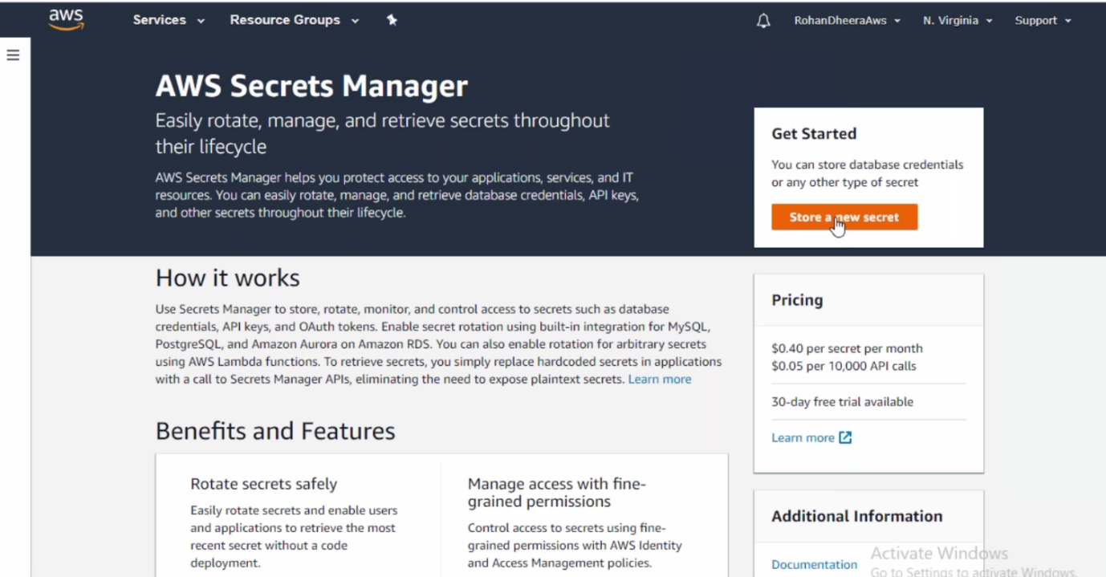

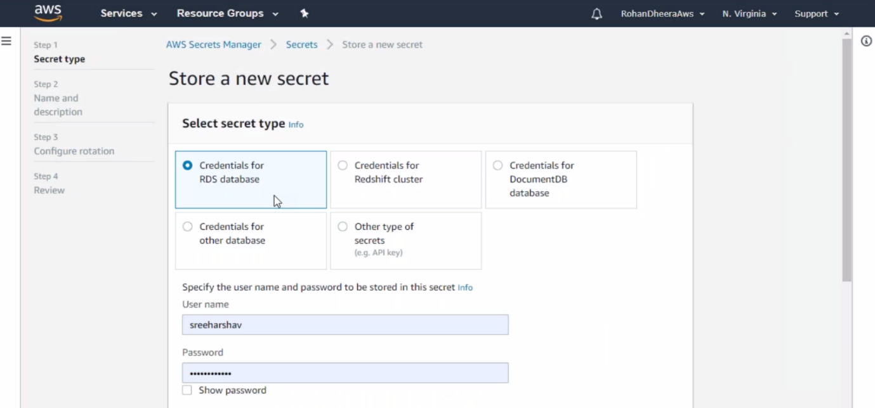

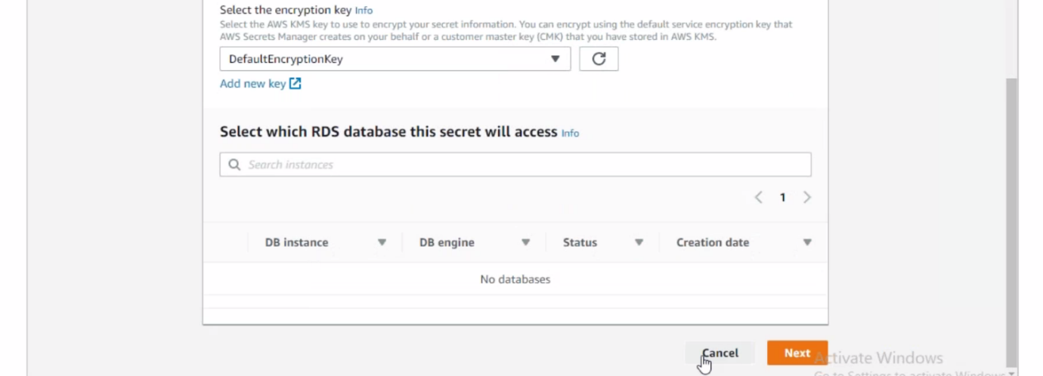

--- if you deploying this data base just give the user name and password that you mentioned here.

--- you don’t have to mention your user name and password except here.

--- this feature more likely used in automation and in cloud formation templates.

**Amazon GuardDuty**

--- in network security you have 2 types of securities 1.IDS (intrusion detection service) 2.IPS(intrusion protective service)

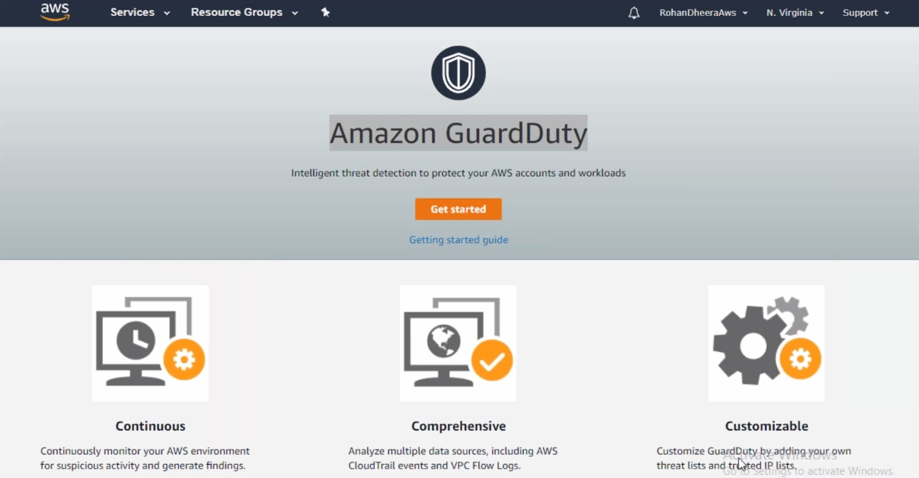

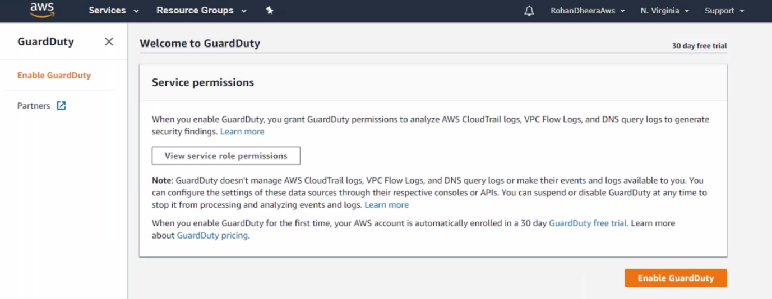

--- we need to enable the GuardDuty.

--- this feature will take all log files form cloud trail and give you detail information if the intruder comes.